<https://www.coursera.org/learn/data-scientists-tools/ungradedWidget/bGdV7/version-control>

**Version Control**

Now that we’ve got a handle on R, RStudio, and projects, there are a few more things we want to set you up with before moving on to the other courses - understanding version control, installing Git, and linking Git with RStudio. In this lesson, we’ll give you a basic understanding of version control.

**What is version control?**

First things first: What is version control? Version control is a system that records changes that are made to a file or a set of files over time. As you make edits, the version control system takes snapshots of your files and the changes, and then saves those snapshots so you can refer or revert back to previous versions later if need be! If you’ve ever used the “Track changes” feature in Microsoft Word, you have seen a rudimentary type of version control, in which the changes to a file are tracked, and you can either choose to keep those edits or revert to the original format. Version control systems, like [Git](https://git-scm.com/), are like a more sophisticated “Track changes” - in that they are far more powerful and are capable of meticulously tracking successive changes on many files, with potentially many people working simultaneously on the same groups of files.

If you’ve ever worked collaboratively on a document before, [this comic](http://phdcomics.com/comics/archive.php?comicid=1531) from PHD Comics might resonate with you.

Hopefully, once you’ve mastered version control software, Paper_Final_FINAL2_actually_FINAL.docx will be a thing of the past for you!

**What are the benefits of using version control?**

As we’ve seen in the example, without version control, you might be keeping multiple, very similar copies of a file. And this could be dangerous - you might start editing the wrong version, not recognizing that the document labelled “FINAL” has been further edited to “FINAL2” - and now all your new changes have been applied to the wrong file! Version control systems help to solve this problem by keeping a single, updated version of each file, with a record of *all* previous versions AND a record of exactly what changed between the versions.

Which brings us to the next major benefit of version control: It keeps a record of all changes made to the files. This can be of great help when you are collaborating with many people on the same files - the version control software keeps track of who, when, and why those specific changes were made. It’s like “Track changes” to the extreme!

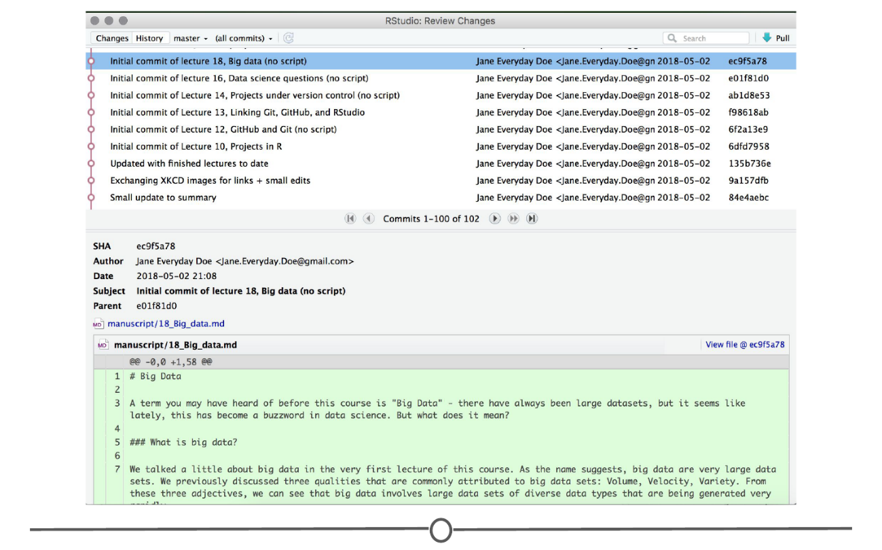

**An example of the version control history for the development of this course!**

This record is also helpful when developing code, if you realize after some time that you made a mistake and introduced an error. You can find the last time you edited that particular bit of code, see the changes you made, and revert back to that original, unbroken code, leaving everything else you’ve done in the meanwhile untouched!

Finally, when working with a group of people on the same set of files, version control is helpful for ensuring that you aren’t making changes to files that conflict with other changes. If you’ve ever shared a document with another person for editing, you know the frustration of integrating their edits with a document that has changed since you sent the original file - now you have two versions of that same original document. Version control allows multiple people to work on the same file and then helps merge all of the versions of the file and all of their edits into one cohesive file.

**What is Git? Why should you use it?**

Git is a free and open source version control system. It was developed in 2005 and has since become *the* most commonly used version control system around! StackOverflow, which should sound familiar from our Getting Help lesson, surveyed over 60,000 respondents on which version control system they use, and as you can tell from the chart below, [Git is by far the winner](https://insights.stackoverflow.com/survey/2017#work-version-control).

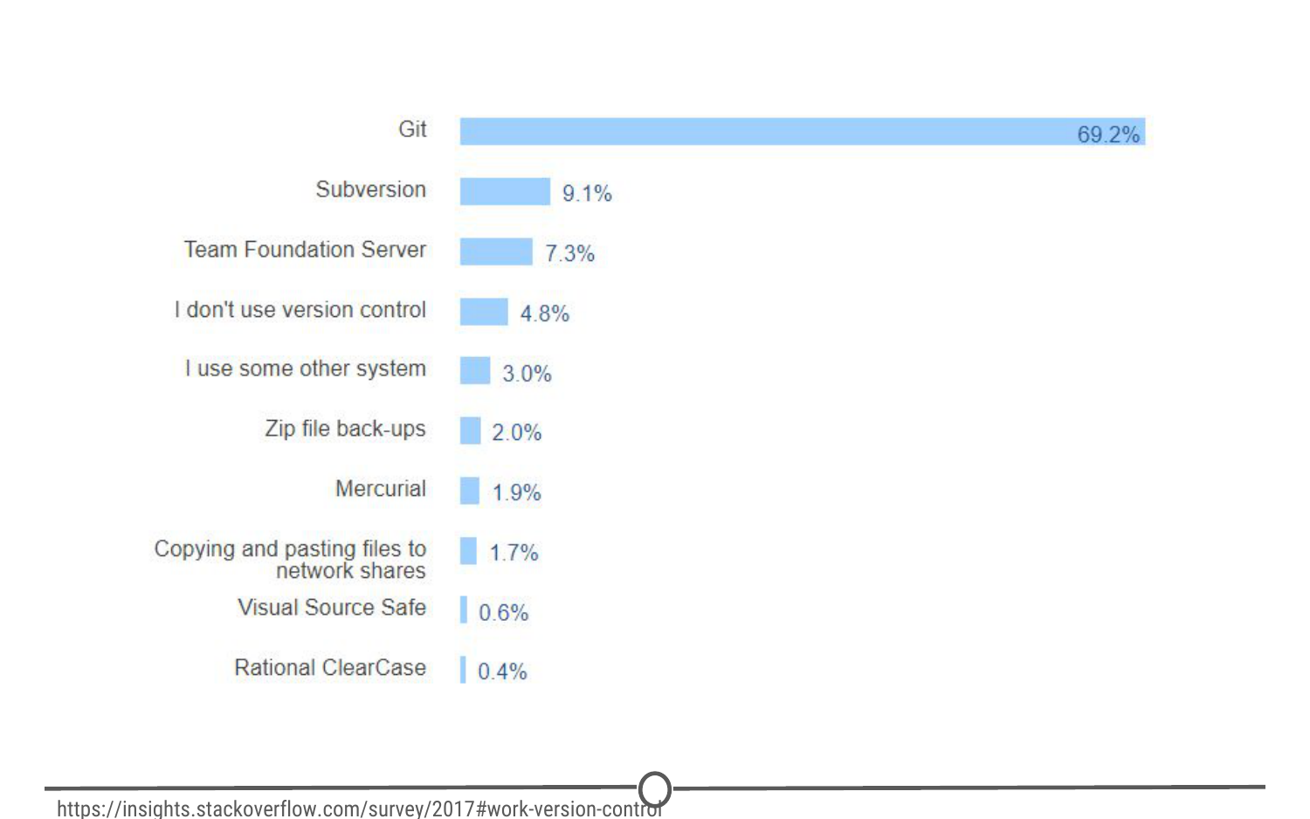

**Results of a StackOverflow survey asking which version control software their respondents use**

And as you become more familiar with Git and how it works and interfaces with your projects, you’ll begin to see why is has risen to the height of popularity. One of the main benefits of Git is that it keeps a local copy of your work and revisions, which you can then edit offline, and then once you return to internet service, you can sync your copy of the work, with all of your new edits and tracked changes to the main repository online. Additionally, since all collaborators on a project have their own local copy of the code, everybody can simultaneously work on their own parts of the code, without disturbing that common repository.

Another big benefit that we’ll definitely be taking advantage of is the ease with which RStudio and Git interface with each other. In the next lesson, we’ll work on getting Git installed and linked with RStudio and making a GitHub account.

**What is GitHub?**

GitHub is an online interface for Git. Git is software used locally on your computer to record changes. GitHub is a host for your files and the records of the changes made. You can sort of think of it as being similar to DropBox - the files are on your computer, but they are also hosted online and are accessible from any computer. GitHub has the added benefit of interfacing with Git to keep track of all of your file versions and changes.

**Version control vocabulary**

There is a lot of vocabulary involved in working with Git, and often the understanding of one word relies on your understanding of a different Git concept. Take some time to familiarize yourself with the words below and read over it a few times to see how the concepts relate.

**Repository:** Equivalent to the project’s folder/directory - all of your version controlled files (and the recorded changes) are located in a repository. This is often shortened to **repo**. Repositories are what are hosted on GitHub and through this interface you can either keep your repositories private and share them with select collaborators, or you can make them public - anybody can see your files and their history.

**Commit:** To commit is to save your edits and the changes made. A commit is like a snapshot of your files: Git compares the previous version of all of your files in the repo to the current version and identifies those that have changed since then. Those that have not changed, it maintains that previously stored file, untouched. Those that have changed, it compares the files, logs the changes and uploads the new version of your file. We’ll touch on this in the next section, but when you commit a file, typically you accompany that file change with a little note about what you changed and why.

When we talk about version control systems, commits are at the heart of them. If you find a mistake, you revert your files to a previous *commit.* If you want to see what has changed in a file over time, you compare the *commits* and look at the messages to see why and who.

**Push:** Updating the repository with your edits. Since Git involves making changes locally, you need to be able to share your changes with the common, online repository. Pushing is sending those committed changes to that repository, so now everybody has access to your edits.

**Pull:** Updating your local version of the repository to the current version, since others may have edited in the meanwhile. Because the shared repository is hosted online and any of your collaborators (or even yourself on a different computer!) could have made changes to the files and then pushed them to the shared repository, you are behind the times! The files you have locally on *your* computer may be outdated, so you pull to check if you are up to date with the main repository.

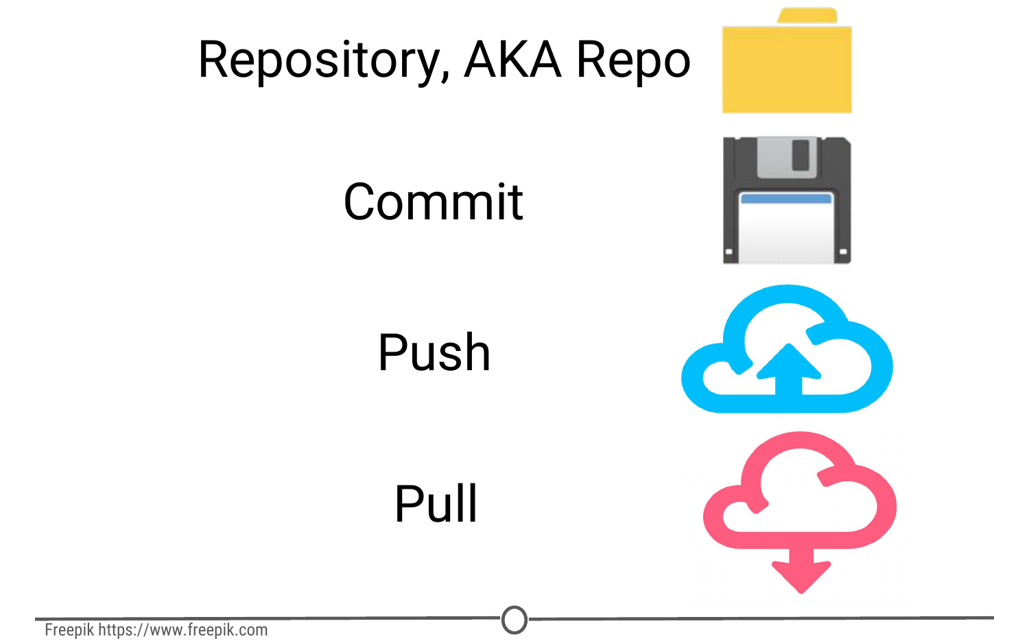

**Analogies to these concepts**

**Staging:** The act of preparing a file for a commit. For example, if since your last commit you have edited three files for completely different reasons, you don’t want to commit all of the changes in one go; your message on why you are making the commit and what has changed will be complicated since three files have been changed for different reasons. So instead, you can stage just one of the files and prepare it for committing. Once you’ve committed that file, you can stage the second file and commit it. And so on. Staging allows you to separate out file changes into separate commits. Very helpful!

To summarize these commonly used terms so far and to test whether you’ve got the hang of this, files are hosted in a **repository** that is shared online with collaborators. You **pull** the repository’s contents so that you have a local copy of the files that you can edit. Once you are happy with your changes to a file, you **stage** the file and then **commit** it. You **push** this commit to the shared repository. This uploads your new file and all of the changes and is accompanied by a message explaining what changed, why and by whom.

**Branch:** When the same file has two simultaneous copies. When you are working locally and editing a file, you have created a branch where your edits are not shared with the main repository (yet) - so there are two versions of the file: the version that everybody has access to on the repository and your local edited version of the file. Until you push your changes and merge them back into the main repository, you are working on a branch. Following a branch point, the version history splits into two and tracks the independent changes made to both the original file in the repository that others may be editing, and tracking your changes on your branch, and then merges the files together.

**Merge:** Independent edits of the same file are incorporated into a single, unified file. Independent edits are identified by Git and are brought together into a single file, with both sets of edits incorporated. But, you can see a potential problem here - if both people made an edit to the same sentence that precludes one of the edits from being possible, we have a problem! Git recognizes this disparity (**conflict**) and asks for user assistance in picking which edit to keep.

**Conflict:** When multiple people make changes to the same file and Git is unable to merge the edits. You are presented with the option to manually try and merge the edits or to keep one edit over the other.

**A visual representation of these concepts, from [https://www.atlassian.com/git/tutorials/using-branches/git-merge**](https://www.atlassian.com/git/tutorials/using-branches/git-merge**)

**Clone:** Making a copy of an existing Git repository. If you have just been brought on to a project that has been tracked with version control, you would *clone* the repository to get access to and create a local version of all of the repository’s files *and all of the tracked changes.*

**Fork:** A personal copy of a repository that you have taken from another person. If somebody is working on a cool project and you want to play around with it, you can fork their repository and then when you make changes, the edits are logged on *your* repository, not theirs.

**Best practices**

It can take some time to get used to working with version control software like Git, but there are a few things to keep in mind to help establish good habits that will help you out in the future.

One of those things is to make purposeful commits. Each commit should only address a single issue. This way if you need to identify when you changed a certain line of code, there is only one place to look to identify the change and you can easily see how to revert the code.

Similarly, making sure you write informative messages on each commit is a helpful habit to get into. If each message is precise in what was being changed, anybody can examine the committed file and identify the purpose for your change. Additionally, if you are looking for a specific edit you made in the past, you can easily scan through all of your commits to identify those changes related to the desired edit.

You don’t want to get in the same habit that [XKCD](https://xkcd.com/1296/) has!

Finally, be cognizant of the version of files you are working on. Frequently check that you are up to date with the current repo by frequently pulling. Additionally, don’t horde your edited files - once you have committed your files (and written that helpful message!), you should push those changes to the common repository. If you are done editing a section of code and are planning on moving on to an unrelated problem, you need to share that edit with your collaborators!

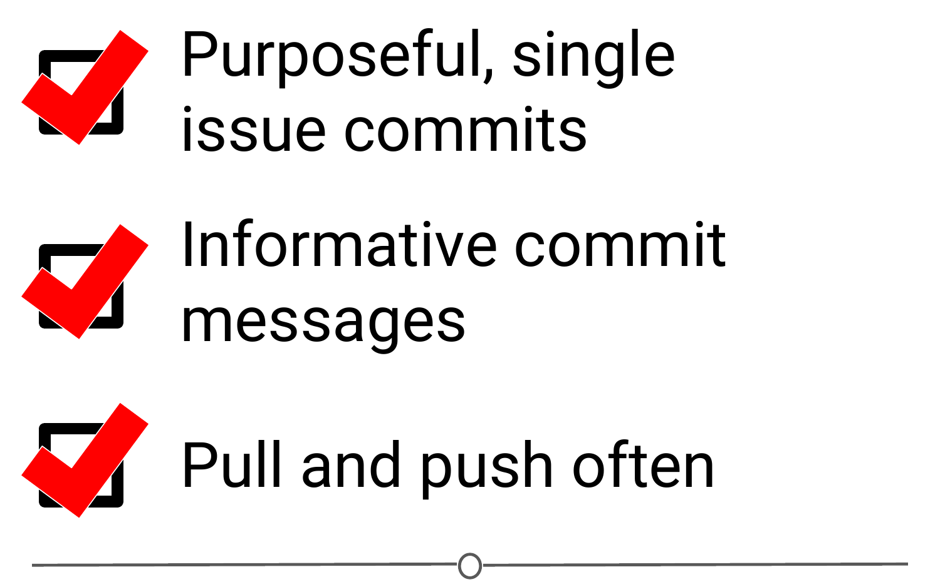

**A summary of the main best practices to keep in mind as you work with version control**

**Summary**

Now that we’ve covered what version control is and some of the benefits, you should be able to understand why we have three whole lessons dedicated to version control and installing it. We looked at what Git and GitHub are, and then covered much of the commonly used (and sometimes confusing!) vocabulary inherent to version control work. We then quickly went over some best practices to using Git – but the best way to get a hang of this all is to use it! Hopefully you feel like you have a better handle on how Git works than the people in [this XKCD comic](https://xkcd.com/1597/)! So let’s move on to the next lesson and get it installed!